TECHNICAL SPECIFICATIONS
for the procurement of safe and licensed workplaces

Table of Contents
1. List of Goods and Delivery Schedule 3
2. List of Related Services and Completion Schedule 3
3. Drawings 5
4. Technical specifications 8
4.1. Deployment Environment 8
4.1.1. On-premise component layout: 8
4.1.2. Public IP Address Summary 10
4.1.3. Next Generation Firewalls (NGFWs) 10
4.1.4. Microsoft Entra ID: 11
4.1.5. Exchange Hybrid: 11
4.1.6. Microsoft 365 Apps (with Teams): 12
4.1.7. Microsoft Defender for Endpoint (MDE): 12
4.1.8. Microsoft Purview Information Protection: 13
4.1.9. Microsoft Purview DLP: 14
4.1.10. Microsoft EOP: 14
4.1.11. Microsoft Intune: 15
4.1.12. Microsoft Defender for Endpoint Plan 2: 15
5. Existing Email Server's mailbox migration to Microsoft Exchange Hybrid(~120 users) 16
5.1. Initial Assessment and Inventory 16
5.1.1. Inventory bootstrap information 16
5.2. Pre-Migration Planning and Coexistence Configuration 17
5.2.1. Migration Tooling and Platform Readiness 18
5.2.2. Pilot Migration Phase (~5–10% of total users) 18
5.2.3. Production Migration Waves (~95 users) 18
5.2.4. Post-Migration Verification 18
6. Provision of Certified Technical Training 19
6.1. Training Scope and Requirements 20
6.1.1. Certified Training Source Requirements 20
6.1.2. Training Delivery Options 20
6.1.3. Training Topics and Alignment with Deployment Components 20
6.1.4. Participant Seats and Customization 20
6.1.5. Documentation and Validation Requirements 21
6.1.6. Language and Format Requirements 21
7. End-User Workshop Delivery – Microsoft 365 Business Premium Services 21
7.1. Workshop Delivery Requirements 21
7.1.1. Number and Format of Workshops 21
7.1.2. Workshop Topics and Scope 21
7.1.3. Language and Accessibility 22
7.1.4. Delivery and Recording Requirements 22
7.1.5. Training Materials and Documentation 22
7.1.6. Trainers and Delivery Team 22
8. Inspections and tests 23
8.1. Purpose and Applicability 23
8.2. Inspection and Validation Deliverables 23
8.3. Testing Categories, Procedures, and Pass Criteria 24
8.4. Milestones and Validation Reports 24
8.5. Configuration Audit Checklist and Evidence Requirements 24
8.6. Performance Validation Benchmarks 25
8.7. Final Acceptance and Payment Conditions 25

List of Goods and Delivery Schedule
The Supplier shall deliver, configure, and activate the Microsoft 365 Business Premium cloud-based enterprise productivity and security suite, in a Hybrid deployment model integrated with the existing on-premises infrastructure. The solution must be delivered within 90 calendar days from contract signing, unless otherwise specified in the implementation schedule.
The Supplier shall ensure timely delivery of the following components:
Article number | Item Description | Quantity/  Scope | Delivery  Deadline  (w/days after signing contract)
CFQ7TTC0LCHC:0002:P1Y:Annual | Microsoft 365 Business Premium P1Y Annual NCE | 120 | 10
CFQ7TTC0HD6T:0001:P1Y:Annual | Microsoft 365 E5 Information Protection and Governance P1Y Annual NCE | 120 | 10
CFQ7TTC0HD6S:0001:P1Y:Annual | Microsoft 365 E5 Insider Risk Management P1Y Annual NCE | 120 | 10
CFQ7TTC0LHQB:0001:P1Y:Annual | Microsoft 365 E5 Security P1Y Annual NCE | 120 | 10
CFQ7TTC0QKW2:0005:P1Y:Annual | Microsoft Defender for Business servers P1Y Annual NCE | 20 | 10
CFQ7TTC0LFK5:0001:P1Y:Annual | Microsoft Entra ID P2 P1Y Annual NCE | 120 | 10
CFQ7TTC0RP76:0002:P1Y:Annual | Microsoft Intune Plan 2 P1Y Annual NCE | 120 | 10
CFQ7TTC0HD6V:0001:P1Y:Annual | Microsoft 365 E5 eDiscovery and Audit P1Y Annual NCE | 120 | 10
N/A | Windows Server 2025, Datacenter Edition(16 core) | 6 | 10

The Supplier shall provide a full delivery plan and Gantt chart during contract initiation.

List of Related Services and Completion Schedule
The Supplier shall provide the following services, fully integrated into the deployment timeline. Each service must be completed by qualified personnel certified by Microsoft or a certified training/reseller partner, and shall include the following scope and timeline commitments(the full requirements and acceptance criteria for each commitment are listed under the Technical specifications point):
Service Description | Deliverable / Outcome | Qty | Physical Unit | Place | Completion Deadline
Kick-off meeting, planning & project governance setup | Signed Project Charter, Work Breakdown Structure (WBS) | 1 | Set | Client premises/  Remote | Within 5 calendar days
Directory synchronization configuration and validation | Entra ID Connect in production, sync scope documented, tested | 1 | System | Client infrastructure | Within 20 days
Hybrid Exchange Deployment & Mail Flow Validation | Operational coexistence, mail routing, Free/Busy, Autodiscover | 1 | System | Client infrastructure | Within 30 calendar days
Mailbox migration to Exchange Hybrid | Successful migration of via Hybrid Move or staged migration path | 120 | Users | Cloud/  On-premises | Migration window agreed with Purchaser
Intune & Endpoint Onboarding Services | Enrollment profiles created; test devices/VDI profiles onboarded, policy baseline applied | 1 | Service | Cloud/  Client devices/VDI Profies | Within 45 days
Security Configuration (MFA, Conditional Access, Defender policies) | Baseline security policies deployed and validated | 1 | Configuration | Cloud/  Client infrastructure | Within 60 days
Information Protection Policies Setup (Sensitivity Labels, DLP, etc.) | Defined data classification structure and policy templates operational | 1 | Configuration | Cloud/  Client infrastructure | Within 60 days
Creation of documentation set (admin guides, SOPs, diagrams, runbooks) | Delivered in Armenian, Russian or English, print-ready PDF and editable formats | 1 | Documentation Set | Digital delivery | Within 75 days
Provision of Certified Technical Training (Administrator-level) | Microsoft Certified Course delivery (online or via voucher with instructor), min. admins trained | 5 | Administrators | Online/  Training facility | Within 80 days
End-User Workshop Delivery (online) | Delivery to ~120 users in Armenian, Russian or English, recordings made available | 2 | Workshops | Online/  Client premises | Finalized by Day 85
Final review, Setup walkthrough, and project sign-off | Signed Acceptance Certificate | 1 | Certificate | Client premises/  Remote | By Day 90

All service deliverables shall be reviewed and approved by the Purchaser’s IT Steering Committee or designated Technical Team. The Supplier is responsible for providing post-deployment technical Q&A sessions for administrators (2 sessions minimum). Purchaser is responsible for the attendance of the technical staff to the Certified Trainings.

Drawings
List of Drawings
Drawing Nr. | Drawing Name
1 | General architecture
2 | Email flow from foreign email sender to the recipients’s Inbox located on-premises Exchange server and Exchange Online through the EOP
3 | Email flow between internal users of the on-premise Exchange server
4 | Email routing flow from on-premise exchange sender Inbox to foreign recipient through the EOP
5 | Active Directory Syncronization with EntraID
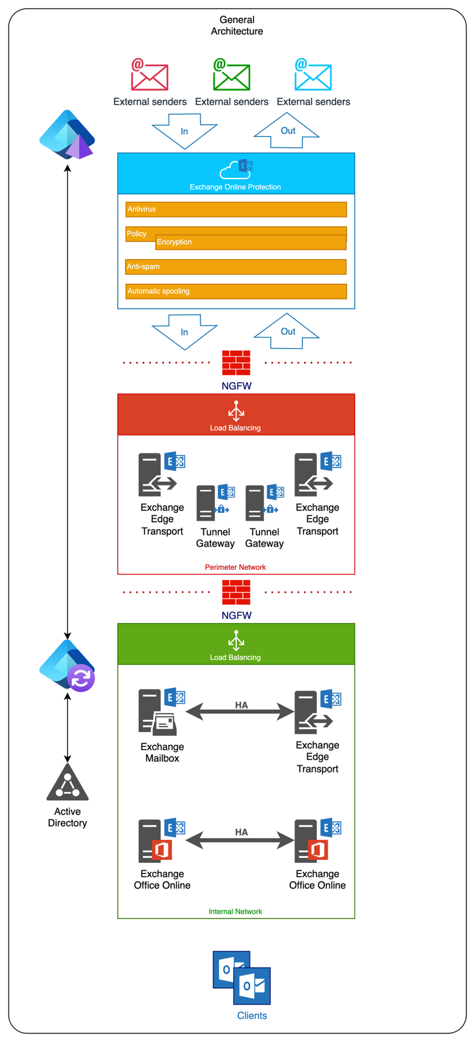
Drawing-1
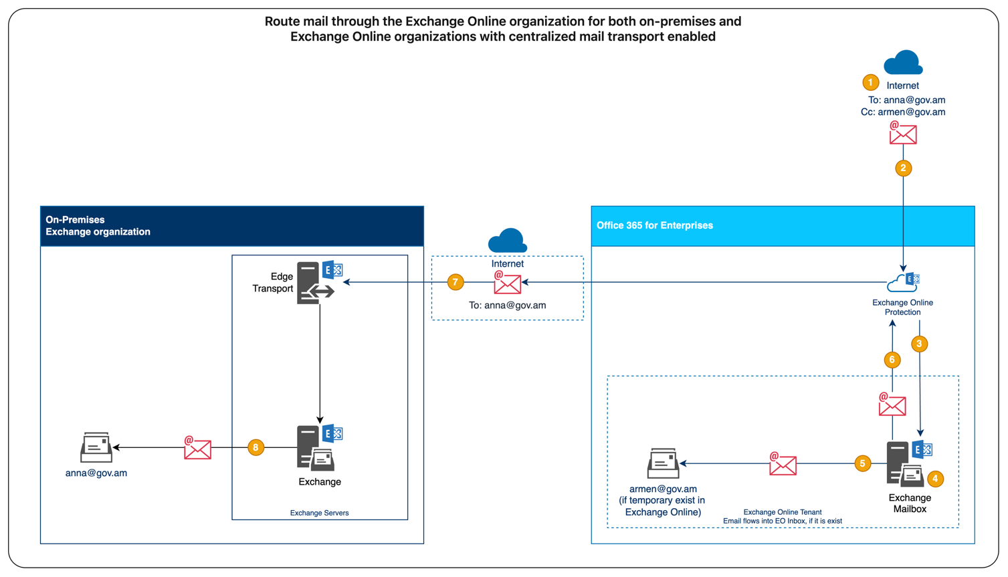
Drawing-2
- Message created on the Internet – The sender addresses mail to anna@gov.am and CCs armen@gov.am.
- MX record points to Exchange Online Protection (EOP) – Because the public MX for gov.am resolves to Microsoft 365, the message first lands in the cloud.
- EOP security filtering – Anti-spam, anti-malware, spoof detection, DKIM/DMARC checks, and other hygiene measures run here. If the message is clean, it’s accepted into the tenant.
- Exchange Online looks up each recipient
  - armen@gov.am has a mailbox in the cloud, so Exchange Online keeps a copy.
  - anna@gov.am is marked as a remote mailbox (on-prem), so her copy needs to be routed to the on-premises organization.
- Internal delivery to Armen’s cloud mailbox – The message is stored in Armen’s Exchange Online mailbox immediately, so he can read it without waiting for on-prem delivery to finish.
- Message prepared for on-prem hand-off – For Anna’s copy, Exchange Online selects the hybrid Send connector that centralized mail transport (CMT) created. This connector forces the traffic back through EOP over TLS.
- Secure transfer from EOP to the on-prem Edge Transport – EOP opens a TLS session to your Edge server (or front-end server if you’re not using an Edge role). Hybrid certificates and connectors ensure the mail is mutually trusted.
- Edge → on-prem Exchange → Anna’s mailbox – The Edge server relays the message to an internal Exchange Mailbox server, and Anna’s mailbox is updated, completing the delivery loop.

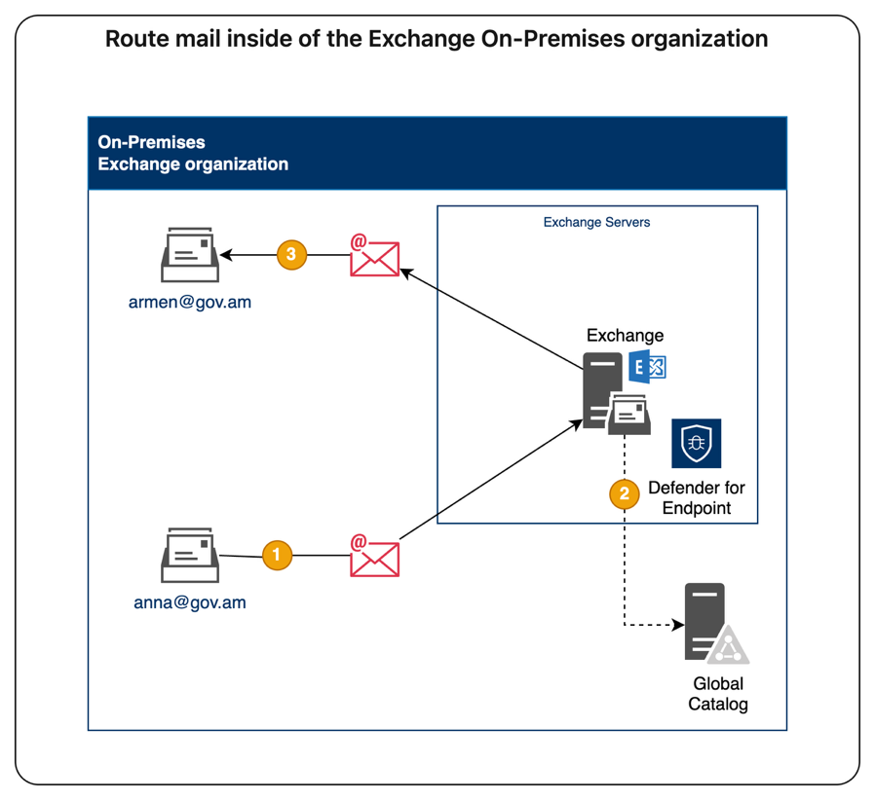
Drawing-3
- Anna, who has a mailbox on the on-premises Exchange Mailbox server, sends a message to an Internal recipient, armen@gov.am.
- The on-premises Exchange server performs a lookup for recipient using an on-premises global catalog server. Through the global catalog lookup, it determines that Armen’s mailbox is located on an on-premises Exchange Mailbox server.
- The on-premises Exchange server delivers the message straight into Armen’s on-prem mailbox database.
The Defender for Endpoint for Servers scanning the file system against viruses.

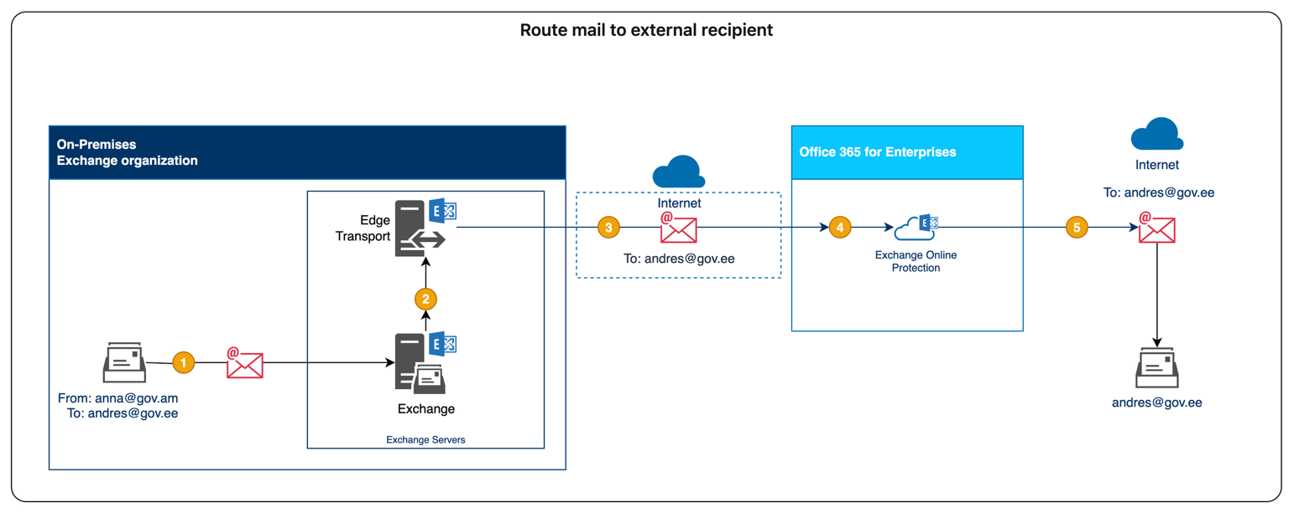
Drawing-4

- Anna sends a message from Outlook; it reaches the on-premises Exchange server.
- Exchange sees that gov.ee is an external domain and forwards the message to Exchange Online Protection (EOP) through the hybrid send connector.
- EOP scans the message for spam / malware and, once cleared, looks up the MX records for gov.ee.
- EOP relays the message to the mail server for gov.ee.
- Andres’s system accepts the mail. Tracking logs in both Exchange and EOP confirm the path: On-prem Exchange → EOP → gov.ee.

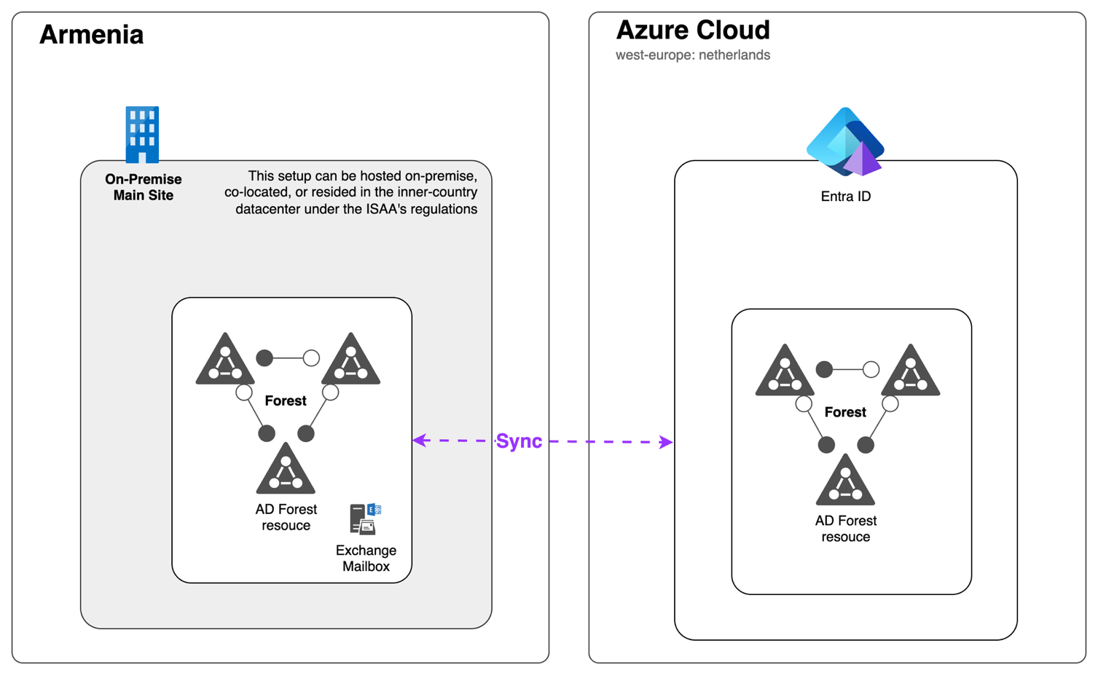
Drawing-5
A hybrid-identity setup:
All Active Directory domain controllers and on-prem Exchange mailboxes stay in Armenia, while Azure AD Connect syncs those identities to Microsoft Entra ID in Azure (West Europe).

Technical specifications
  - Deployment Requirements:
The vendor shall configure the infrastructure components listed below using physical or virtualized servers provided by the procuring organization. The vendor is responsible for complete installation, configuration, integration, testing, complete documentation and knowledge transfer of the installation & configuration of each service, app, server listed in the technical specification. The architecture must support 120 users, each with an estimated ~10 GB mailbox size, requiring proper sizing for performance, high availability (HA), and hybrid functionality.

Deployment Environment

On-premise component layout:
  - 2x Exchange Mailbox servers
    - Role: Mailbox Server Role (Hybrid)
    - Users: 120 (hybrid; expect co-existence/migration)
    - Mailbox Size: Average 10 GB per user → Total ≈ 1.5 TB storage
    - OS: Windows Server 2025, Standart Edition
    - Exchange Version: Exchange Server Latest version (Hybrid-supported)
    - CPU: ≥ 12 cores per server (64-bit)
    - RAM: ≥ 64 GB per server
    - Disk:*
      - 1x OS volume (≥ 100 GB SSD)
      - 1x DB volume (≥ 2 TB, RAID 10, fast storage)
      - 1x Log volume (≥ 1 TB, RAID 10)
    - Network: 2x NICs (Internal/Management + Mail Flow/HA)
    - IP Requirements: 2x internal static IPs (LAN)
    - Public IP: Not required (protected by Edge Transport)
*Vendor must calculate exact IOPS requirements based on user concurrency model.
  - 2x OOS (Office Online Server)
    - Role: Document rendering for Exchange/SharePoint
    - OS: Windows Server 2025 Datacenter
    - Software: Latest Office Online Server Latest Version (OOS)
    - CPU: ≥ 4 cores
    - RAM: ≥ 16 GB
    - Disk: ≥ 100 GB
    - Network: 2x NICs
    - IP: 2x internal static IPs
    - Public IP: Not required
  - 2x Edge Transport Servers in DMZ
    - Role: Secure SMTP relay for Exchange Hybrid
    - OS: Windows Server 2025 Datacenter edition
    - Exchange Role: Edge Transport
    - CPU: ≥ 4 cores
    - RAM: ≥ 8 GB
    - Disk: ≥ 100 GB
    - Network: 2x NICs (DMZ + LAN)
    - IP Requirements:*
    - 2x internal static IPs (DMZ segment)
    - 2x public IPs (1 per Edge Transport for inbound SMTP)
*DNS and TLS certificates must be configured to support proper mail routing.
  - 2x Hardware or Virtual Load Balancers (Mailbox + OOS)
    - Role: HTTPS L7 Load Balancing
    - Platform: HAProxy / NGINX or equivalent Hardware/Software appliance
    - CPU: ≥ 2 cores
    - RAM: ≥ 4 GB
    - Disk: ≥ 20 GB
    - Network: 2x NICs
    - IP Requirements:*
    - 2x internal static IPs
    - 1x public IP (shared VIP for Exchange & OOS access)
*TLS passthrough or termination to be designed according to Exchange Hybrid requirements.
  - 2x Load Balancers (Edge Transport)
    - Role: SMTP L4/L7 Load Balancing
    - Platform: HAProxy / NGINX or equivalent Hardware/Software appliance
    - CPU: ≥ 2 cores
    - RAM: ≥ 4 GB
    - IP Requirements:*
    - 2x internal static IPs (DMZ)
    - 1x public IP (VIP for SMTP inbound)

Public IP Address Summary
Component | Public IPs Required | Purpose
Edge Transport Servers | 2 | SMTP mail flow (1 per server)
Load Balancer (Mailbox/OOS) | 1 | HTTPS traffic for Exchange/OOS
Load Balancer (Edge Transport) | 1 | SMTP delivery NAT
NGFW (provided by Procurer) | 1–2 | VPN, NAT, outbound filtering
Total Estimated | 5–6 (+1-2 reserved for non expected cases) | Depending on NAT, firewall clustering, and policy
*The vendor must coordinate with the infrastructure team to allocate public IPs from the existing IP Pool or BGP-announced subnet. All mappings must be documented.

Next Generation Firewalls (NGFWs)
The procuring organization already operates a production-grade, enterprise-class NGFW solution (High Availability).
The vendor shall work in close coordination with the Purchaser’s technical team to:
- Review existing NGFW configuration and rule sets relevant to Microsoft 365 and Exchange Hybrid
- Define and implement required NAT, ACLs, and service rules to enable Exchange Hybrid mail flow and management plane access (Autodiscover, Free/Busy, SMTP, EWS, MRS, OAB, etc.)
- Validate necessary inbound/outbound ports, protocols, and IP addresses based on Microsoft’s published Hybrid deployment documentation
- Assist in SSL/TLS certificate handling, decryption policy alignment, and mail protection flow verification
- Ensure coexistence with Edge Transport servers and Email Security Gateways without policy conflicts
- Coordinate IP address assignments for Exchange Hybrid components (Edge Transport, ESGs, Load Balancer VIPs) and their firewall zones
- Validate hybrid mail routing paths (inbound/outbound SMTP, DNS resolution) through existing NGFW
- Configure or verify logging of mail flow and hybrid-related traffic to Purchaser’s centralized SIEM
- Document integration points, ruleset changes, and provide rollback plans if needed
- Perform knowledge transfer to Purchaser’s security and infrastructure teams regarding firewall policy impacts on Microsoft 365 Hybrid services

Success criteria:
All firewall rules, NAT configurations, and network policies required for Exchange Hybrid functionality were successfully implemented on the existing NGFW platform in coordination with the Purchaser’s technical team. Mail routing, Autodiscover, Free/Busy, and management endpoints were validated for hybrid users. Firewall logs confirm appropriate rule hits and threat inspection coverage without disruption. Integration with Microsoft 365 Defender and SIEM is verified. Documentation covering policy changes, hybrid access paths, and rollback options is delivered. Knowledge transfer is completed, and the integration is approved by the Purchaser’s network and security stakeholders. Everything listed in success criteria must be delivered if the appliance supports and licenses are in place for the features.

Microsoft Entra ID:
- Check and Configuring the Active Directory infrastructure
- Local network readiness assessment for Entra Connect
- Check and Configuring servers for Entra Connect
- Configuring Entra Connect
- Configuring Entra ID MFA
- Configuring Entra ID conditional access policies
- Configuring Entra ID SSPR
- Configuring Entra ID single sign-on (SSO)
- Configuring Entra ID hybrid join
- Configuring Entra ID group-based licensing
- Configuring Entra ID Protection
- Configuring Risk Based Conditional Access
- Configuring Privileged Identity Management
- Demonstrating advanced security reports
- Troubleshooting Entra ID configuration

Success criteria:
All stages were successfully completed, configured Active Directory infrastructure, assessed the readiness of the network to work, configured servers for Entra Connect, configured Entra Connect, configured Entra ID MFA, conditional access policy, SSPR, SSO, hybrid join, group-based licensing, configured ID Protection, Risk Based CA and PIM, demonstrated features advanced security reports, performed Entra ID configuration troubleshooting, performed Entra ID knowledge transfer.

Exchange Hybrid:
- Check and Configuring local Exchange Server infrastructure
- Local network readiness assessment for Exchange Hybrid
- Check and Configuring SMTP/DNS infrastructure
- Configuring Exchange Hybrid (2xMailbox servers, 2xOOS servers, 2xEdge transport servers, 2xLB for Mailbox+OOS, 2x LB for edge transport)
- Mailbox migration from Exchange Server to Exchange Online
- Mailbox migration from Exchange Online to Exchange Server
- Testing and troubleshooting Exchange Hybrid configuration

Success criteria:
All stages were successfully completed, configured Exchange Server and SMTP/DNS infrastructure, assessed the readiness of the network to work Exchange Hybrid, configured Exchange Hybrid, performed migration of mailboxes, tested and troubleshooted Exchange Hybrid configuration issues, Autodiscover, mail routing (inbound/outbound), TLS certificate exchange, Free/Busy calendar sharing, and coexistence scenarios were validated. Hybrid health status was verified, and users successfully migrated and tested. Documentation provided included deployment diagrams, DNS configurations, and rollback plans, HA tests were passed successfully for all roles (Mailbox, OOS, Edge Transport and LBs), performed Exchange Hybrid knowledge transfer.

Microsoft 365 Apps (with Teams):
- Check and configuring tenant Microsoft 365 for Intune
- Assessing the readiness of all devices for Intune
- Check and configuring Active Directory infrastructure
- Configuring Entra Connect
- Creating and configuring device enrollment scripts for all devices
- Enroll devices in Intune
- Developing and configuring compliance policies for devices
- Developing and configuring configuration profiles for devices
- Developing and configuring conditional access policies for devices
- Developing and configuring app protection policies for devices
- Developing and configuring app configuration policies for devices
- Demonstrate the capabilities of Intune reports
- Testing and troubleshooting Intune configuration

Success criteria:
All stages were successfully passed, Microsoft 365 tenant configured, Active Directory and Entra Connect infrastructure configured, network and user device readiness for Intune assessed, Intune device registration script configured, Intune device registration performed, device compliance policies and configuration profiles configured, conditional access policies configured, application protection and configuration policies configured, Intune reporting capabilities demonstrated, Intune configuration testing and troubleshooting performed, Intune knowledge transfer performed, Intune configuration detailed documentation is written and transfered to client and Intune configuration and security policies configured, Device onboarding was validated for Windows, MacOS, iOS, and Android. Compliance and configuration policies enforced across test users. Remote lock/wipe, policy conflict resolution, and tenant health metrics were verified. Success also includes fully operational Endpoint Analytics and secure score improvements.

Microsoft Defender for Endpoint (MDE):
- Validation and configuration of Microsoft 365 tenant for MDE
- Assess readiness of devices for MDE
- Verify network connectivity and bandwidth requirements for MDE
- Verify and configure the on-premises Active Directory infrastructure
- Determine deployment strategy and select the best method to deploy MDE
- Preparing of endpoints for MDE deployment
- Onboarding MDE agents to endpoints
- Configuring "Next-generation protection" for users
- Configuring "Attack surface reduction" for users
- Configuring and demonstrating "Device discovery", "Device inventory", Demonstrating "Security Reports"
- Configuring and demonstrating "Core Defender Vulnerability Management" for users
- Configuring and demonstrating "Threat Analytics"
- Configuring and demonstrating "Automated investigation and response", "Advanced hunting"
- Configuring and demonstrating "Endpoint detection and response"
- Testing and troubleshooting MDE configuration

Success criteria:
All stages were successfully completed, assessed the existing infrastructure, prepared MDE requirements, verified network connectivity and bandwidth, selected an MDE deployment strategy, configured MDE agents on all devices and machines, configured policies on all devices and machines, configured "Next-generation protection", "Attack Surface Reduction", performed a demonstration of "Security Reports", configured and performed a demonstration of "Device Discovery" and "Device Inventory", configured and performed a demonstration of "Core Defender Vulnerability Management", "Threat Analysis", "Automated Investigation and Response", "Advanced hunting" , performed MDE configuration troubleshooting, performed MDE knowledge transfer, MDE configuration detailed documentation is written and transfered to client.

Microsoft Purview Information Protection:
- Creating and configuring sensitive data types (built-in, regex, dictionary)
- Demonstrating advanced options for configuring sensitive data types (Exact Data Match, Trainable Classifiers)
- Creating and configuring Microsoft Purview Information Protection sensitivity labels
- Creating and configuring Microsoft Purview Information Protection policies
- Demonstrating advanced sensitivity labelling features (Teams, M365 Groups, SharePoint Sites)
- Demonstrating Information Protection Scanner capabilities
- Demonstrating Office 365 Message Encryption (OME) capabilities
- Demonstrating automatic document categorization capabilities
- Testing and troubleshooting Information Protection configuration

Success criteria:
All stages were successfully completed, configured confidential data types, demonstration of advanced options for configuring confidential data types, setting sensitivity labels, creating Purview Information Protection policies, demonstration of advanced sensitivity labeling capabilities, demonstration of advanced sensitivity labeling functions, information security scanner capabilities, Office 365 message encryption capabilities, demonstration of automatic document categorization capabilities, performed Information Protection configuration troubleshooting, performed Information Protection knowledge transfer, Microsoft Purview Information Protection configuration detailed documentation is written and transfered to client.

Microsoft Purview DLP:
- Creating and configuring a Microsoft Purview DLP policy for Microsoft 365 services
- (OneDrive, SharePoint, Exchange Online & Exchange On-Premise, Teams, Endpoint DLP)
- Creating and configuring manual retention labels, rules-based automatic retention policies
- Testing the performance of Microsoft Purview DLP policies
- Demonstrating advanced DLP features
- Testing and troubleshooting DLP configuration

Success criteria:
DLP policies deployed and operational across all M365 workloads. Data exfiltration attempts simulated and blocked per policy design. Manual and rules-based retention settings enforced correctly. Endpoint DLP confirmed with user notification and blocking capabilities. DLP audit logs generated and visible in compliance portal. Advanced DLP rules demonstrated with keyword detection, fingerprinting, and sensitive info types. Full documentation delivered including policy mappings, rule logic, user education material, and escalation paths. Security, compliance, and records management personnel trained on policy lifecycle management.

Microsoft EOP:
- Configuring anti-spam and anti-malware policies
- Configuring connection and spam filter policies
- Configuring outbound spam filtering
- Configuring spoof intelligence and domain authentication (SPF, DKIM, DMARC)
- Configuring quarantine policies and user notification settings
- Configuring mail flow rules (transport rules) for additional protection
- Enabling Zero-hour auto purge (ZAP)
- Enabling Microsoft 365 Defender integration for unified reporting
- Testing and simulating spam and malware flows
- Troubleshooting EOP configurations and mail delivery issues

Success criteria:
All EOP protection policies deployed and confirmed through real-world and simulated email flows. Domain authentication standards (SPF, DKIM, DMARC) validated via external testing. Quarantine notifications and portal access functional. Defender portal integration confirmed for visibility. ZAP tested with sample threats. Configuration fully documented including routing topology, transport rules, and exception cases. Knowledge transfer conducted with mail administrators, including anti-spam tuning guidance and troubleshooting workflows.

Microsoft Intune:
- Configuring Device onboarding & Windows Autopilot
- Configuring compliance policies & conditional access integration
- Setup of configuration profiles
- Setup of application lifecycle management
- Enabling and configuring app protection policies(MAM)
- Setup of endpoint security profiles
- Setup of Widows update for Business rings
- Configuring and demonstrating on test devies remote actions(wipe, retire, lock, passcode reset)
- Demonstrating reporting & basic analytics
- Configuring and demonstratnig RBAC & administrative scopes
- Troubleshooting configurations and service interdependencies

Success criteria:
Deployment is considered complete when every Windows, iOS/iPadOS, macOS and Android device (new or existing) enrolls through Autopilot or its native MDM path with correct ownership, naming and baseline settings; compliance rules reliably assess device health and trigger Conditional Access to block or quarantine anything out of spec; configuration profiles push required security, networking and productivity policies on first sync and remain error-free afterward; apps (Win32, Store, VPP, line-of-business and web) install, update and remove automatically according to group assignments; mobile app protection enforces PIN, encryption and data-sharing restrictions on both managed and personal devices; endpoint security templates enable Defender AV, BitLocker, firewall and attack-surface controls and show “succeeded” status; Windows Update for Business rings deliver patches and feature releases on schedule with no deadline misses; remote actions, wipe, retire, lock and passcode reset, execute on test devices within 15 minutes and generate matching audit logs; dashboards accurately reflect compliance, deployment and update posture across all pilot endpoints; RBAC scopes let support teams manage devices without tenant-wide rights, confirmed through least-privilege tests; and any interdependency issues uncovered during the pilot are resolved, documented and successfully retested to ensure end-to-end stability.

Microsoft Defender for Endpoint Plan 2:
- Activating Defender for Endpoint Plan 2 licensing in Microsoft 365 Defender
- Configuring attack surface reduction rules (ASR) and device control
- Enabling endpoint detection and response (EDR) in block mode
- Onboarding endpoints using group policy, Microsoft Intune, or script-based methods
- Configuring Automated Investigation and Response (AIR)
- Enabling advanced hunting and custom detection queries
- Integrating threat analytics and incident response workflows
- Enabling device isolation, file analysis, and live response
- Validating indicators of compromise (IoCs) and exclusion policies
- Testing multi-platform support (Windows, macOS, Linux)
- Providing troubleshooting support for agent deployment and detection visibility

Success criteria:
Defender for Endpoint Plan 2 features are fully activated and tested across all supported platforms. All endpoint onboarding methods are functional and confirmed on Windows, macOS, and Linux. ASR rules, device control, EDR in block mode, and AIR are operational and verified. Advanced hunting queries demonstrate relevant telemetry and threat detection capability. Threat analytics, live response, and isolation capabilities are configured and successfully simulated. IoCs and exclusions are verified. Technical documentation covering policy configuration, deployment methodology, and operational playbooks is delivered. Knowledge transfer sessions conducted for SOC analysts and IT administrators, with hands-on demonstration of Defender capabilities.

Existing Email Server's mailbox migration to Microsoft Exchange Hybrid(~120 users)
  - Migration Requirements:
The vendor shall plan, execute, and support the full migration of ~120 production user mailboxes from an on-premises Exchange Servers (legacy email system) to the newly deployed Microsoft Exchange Hybrid environment if it is necessary and agreed with IT suport team, ensuring secure, reliable, and auditable data transfer with zero data loss, minimum user impact, and full coexistence during the transition.
The vendor is responsible for:

Initial Assessment and Inventory
- Perform a complete inventory of all mailboxes (active, shared, resource), distribution groups, aliases, public folders (if any), and user access rights from the existing Exchange server platform.
- Identify non-mailbox items (e.g., calendar entries, tasks, rules, contacts) and confirm migration feasibility per item type.
- Analyze mailbox sizes, message counts, attachments, folder structures, custom flags, and character sets (including Unicode/UTF-8).
- Assess source MS Exchange version and environment health for compatibility and stability.
- Map user identity schema (username/email/UAN) to Entra ID synchronized identities for seamless login post-migration.

Inventory bootstrap information
Group | No | Question | Response
 | Common questions about current Active Directory Infrastructure
 |  | Local Active Directory forest/domain name | isaa.am
 |  | Local Active Directory subdomains | 0
 |  | Local Active Directory Domain Controllers Qty. | 2
 |  | Local Active Directory Domain Controllers OS version | Windows Server 2022
 |  | Local Active Directory Forest Functional Level | Windows Server 2022
 |  | Local Active Directory Domain Functional Level | Windows Server 2022
 |  | Local Active Directory Domain’s Total Number of Objects  - Users  - Groups  - Computers | 188  91  108
 |  | Local Active Directory Domain Joined Endpoint OS version Percentage  e.g  - MacOS (%)  - Windows 11 (%) | 1%  99%
 |  | Local Active Directory Domain Joined Endpoint MS Office version Percentage  e.g  - Office 365 Apps for business (%)  - Office 365 Business Standard (%) | 92%  13%
 | Common questions about current Email Infrastructure
 |  | Total number of mail servers | 2
 |  | Version and Build of the mail server operating system | Windows Server 2022 Standard 64-bit build 20348 10.0.20348
 |  | Version of the mail system | MS Exchange Version 15.2 (Build 1544.4)
 |  | Public mail (SMTP) domain names | mail.isaa.am
 |  | Total number of user mailboxes | 169
 |  | Total volume of user mailboxes | 180.5 GB
 |  | Critical information systems integrated with email system | AS, isaa.am Website, NextCloud, Slack, ClickUP
 |  | Information security systems integrated with the mail system (anti-spam, anti-virus, sandbox, DLP, etc.) | Fortigate
 |  | Email Client Apps Version Percentage  - MS Outlook (%)  - Apple Mail (%) | 90%  10%
 |  | Email Client Access to Email System from Internet | WebMail
 | Common questions about current Microsoft 365 Infrastructure (if applicable)
 |  | Microsoft 365 Tenant (TenandID) | ae9c66fd-741c-4a1c-b3c9-11390a5eb296
 |  | Microsoft 365 Licenses (Already procured and available for use) Qty. | O365-135
 |  | Microsoft 365 Users Qty. | -
 |  | Microsoft 365 Cloud Services (Activated, Used) | Teams – 25/10
 |  | Microsoft 365 Exchange Online Total Number of Mailboxes | -

Pre-Migration Planning and Coexistence Configuration
- Design migration phases (pilot + production waves) aligned to business priorities.
- Establish migration batch criteria (size, role, department, mailbox volume).
- Configure SMTP mail flow coexistence during transition:
  - Ensure split-domain routing or sub-domain-based redirection.
  - Validate mail relay from Exchange Servers (legacy email system) to Exchange Online via Edge Transport servers.
  - Setup temporary coexistence for Free/Busy lookups (if possible).
- Verify autodiscover redirection behavior for Outlook clients and plan DNS cutovers.
- Document fallback/rollback procedures and downtime window tolerances.

Migration Tooling and Platform Readiness
- Select and license appropriate migration tool compatible with Exchange Servers (legacy email system) to Exchange Online or Exchange Server (e.g., Online Email Migrator, Azure container, vendor-developed script-based tooling).
- Validate migration tool feature set for:
  - Full-fidelity mailbox migration (including folder structure, flags, attachments, and metadata)
  - Delta sync and throttling management
  - Error handling, retry mechanism, reporting
- Provision migration endpoints, user impersonation, OAuth scopes, or admin access in both source and destination systems.
- Ensure secure data transmission (TLS 1.2 or higher) between source and destination.
- Prepare network bandwidth estimates and schedule migration batches to avoid business hour disruption.

Pilot Migration Phase (~5–10% of total users)
- Migrate a test group of 6-12 users representing various mailbox sizes, departments, and access patterns.
- Verify complete data integrity (mail, calendar, contacts, rules, attachments).
- Test sign-in to Exchange Online, M365 Apps, and mobile access.
- Evaluate client configuration changes required for Outlook profiles (Autodiscover redirection, re-creation).
- Obtain user feedback and resolve technical or usability issues before proceeding.

Production Migration Waves (~95 users)
- Execute staged migration waves in defined groups.
- Provide continuous reporting: batch status, success/failure rates, migrated items per user.
- Notify users of migration schedules, expected impacts, and required client reconfigurations.
- Support desktop/mobile reconfiguration and profile resets post-migration.
- Verify mail routing integrity for inbound/outbound SMTP and internal routing across hybrid users.

Post-Migration Verification
- Perform end-user validation checks for each batch:
  - Email delivery, mailbox structure, calendar entries
  - Contact lists, message search, attachments, rules
- Verify service health using Microsoft 365 Service Health dashboard, Hybrid Configuration Wizard, and Test-ExchangeConnectivity tools.
- Run audit reports to identify skipped items or failures and initiate re-syncs where necessary.
- Decommission Exchange Servers (legacy email system) gradually post-final user migration and archive extraction.
- Document all migration scripts, schedules, configuration snapshots, and user instructions.
User Support and Training
- Provide user-facing guidance materials (Armenian, Russian or English) for mail access post-migration, password management, Outlook reconfiguration, and mobile setup.
- Support IT staff in updating device management policies (Intune profiles, Outlook app enforcement).
- Establish escalation support channel for mailbox issues within 7 days post-migration.

Success Criteria:
- Full migration of ~120 user mailboxes completed from Exchange Servers (legacy email system) to New Microsoft Exchange Hybrid.
- No data loss or corruption confirmed via checksum, item counts, and user validation.
- All user mailbox data (emails, calendar entries, contacts, folders, rules, tasks) migrated with integrity.
- SMTP mail routing validated (inbound, outbound, hybrid routing), Free/Busy tested.
- Outlook Autodiscover and profile reconfiguration validated across user endpoints.
- Hybrid configuration confirmed functional via Microsoft Hybrid Configuration Wizard (HCW), including OAuth, connectors, certificates, federation, and calendar sharing.
- Full documentation provided, including:
  - User migration inventory with success/failure logs
  - Tool configuration and batch migration plans
  - DNS change logs and Autodiscover cutover timeline
  - Fallback/rollback plans and issue resolution matrix
- User support and satisfaction validated through ticket tracking and migration feedback forms.
- Knowledge transfer sessions completed for IT administrators on mailbox migration methodology, troubleshooting tools, and post-migration support.

Provision of Certified Technical Training
  - Objective
The vendor shall provide comprehensive technical training aligned with the deployed Microsoft 365 and infrastructure services, covering all components listed in the deployment requirements. Trainings must enable the procuring organization’s technical staff to operate, maintain, and evolve the deployed systems in line with vendor best practices and security guidelines.

Training Scope and Requirements

Certified Training Source Requirements
All courses must meet the following certification and delivery criteria:
- Trainings shall be delivered directly by the solution Manufacturer (e.g., Microsoft), or by a certified training partner authorized by the respective Manufacturer.
- All participants must receive official certificates of completion, digital badges, or other verifiable credentials issued by the Manufacturer or its authorized training partner.

Training Delivery Options
The vendor may offer:
- Public instructor-led courses
- Corporate training vouchers redeemable through Manufacturer/authorized partner platforms(with instructor)
- Private group training sessions (online/offline, with instructor)
All training modes must ensure full access to hands-on labs, practice environments, and official courseware.

Training Topics and Alignment with Deployment Components
The vendor shall deliver or facilitate training covering the following areas:
Training Course / Track | Training Provider | Minimum seats
Microsoft 365 Certified:  Administrator expert | Microsoft / MCT Partner | 5
Microsoft 365 Certified:  Endpoint Administrator Associate | Microsoft / MCT Partner | 5
Microsoft 365 Certified:  Collaboration communications systems engineer associate | Microsoft / MCT Partner | 5
Microsoft 365 Certified:  Teams Administrator Associate | Microsoft / MCT Partner | 5
Microsoft Certified:  Information Security Administrator Associate | Microsoft / MCT Partner | 5
Microsoft Certified:  Cybersecurity Architect Expert | Microsoft / MCT Partner | 5
Microsoft Certified:  Windows Server Hybrid Administrator Associate | Microsoft / MCT Partner | 5

Participant Seats and Customization
- The vendor shall provide certified training access for a minimum of five (5) technical staff per subject area.
- Trainings must be scheduled to accommodate staff availability and operational continuity.
- Upon request, the vendor shall arrange customized or consolidated training tracks that cover multiple related components (e.g., combined M365 security services training).

Documentation and Validation Requirements
- The vendor shall provide an official training plan with course titles, links to official course description pages, delivery mode, expected duration, and certification output.
- After completion, the vendor must submit:
  - List of trained personnel with certificate serial numbers or URLs
  - Copies of all completion certificates
  - Summary report on training attendance and performance (if available)

Language and Format Requirements
- All trainings must be delivered in Armenian, Russian or English with written materials available in Armenian, Russian or English.
- Supplementary support or clarification sessions may be optionally requested in Armenian, Russian or English if arranged with the training provider.

Success Criteria
The training is considered successfully delivered when:
- All listed courses are completed by designated staff with official attendance certificates provided.
- Access to course material and labs is verified.
- The training content is aligned with deployed technologies and enables post-deployment maintenance and enhancement.
- Feedback from staff confirms learning objectives were met.

End-User Workshop Delivery – Microsoft 365 Business Premium Services
  - Objective
To support the successful adoption of the Microsoft 365 Business Premium platform and ensure smooth transition to the new Exchange Hybrid environment, the vendor shall deliver structured end-user workshops focused on training the organization’s ~120 users in the practical usage of Microsoft 365 Business Premium services. These workshops shall be designed to build foundational skills and digital literacy among users, enabling them to fully utilize the services provided under the scope of this tender.

Workshop Delivery Requirements

Number and Format of Workshops
- A total of two (2) end-user online workshops(with instructor) sessions shall be delivered via Microsoft Teams or equivalent platform by the vendor:

Workshop Topics and Scope
Workshops shall strictly cover only the Microsoft 365 Business Premium services included in the current procurement. Topics must focus on practical, user-facing scenarios, including but not limited to:
- Introduction to Microsoft 365 Business Premium Services: Overview of integrated tools (Outlook, Teams, OneDrive, Word/Excel/PowerPoint Online, SharePoint).
- Modern Workstation Experience: Working securely from anywhere, collaboration tools, online meetings, file sharing, and productivity tips.
- Outlook Desktop and Web: Calendar, email organization, meeting scheduling, mobile sync, shared mailboxes.
- Microsoft Teams: Chat, calls, meetings, channels, file collaboration, presence indicators.
- OneDrive and SharePoint Online: Cloud file storage, sharing, versioning, syncing, and co-authoring documents.
- Microsoft 365 Apps: Office Online usage and desktop Office suite integration.
- Security Features for End-Users: MFA experience, secure sharing, recognizing phishing, and data protection best practices.
- Support Resources: How to get help, reset passwords, use Microsoft support and self-service tools.
- File protection, labeling, DLP, etc.
Workshops shall not include training on services or capabilities outside of the procured M365 Business Premium services scope. Topics such as Microsoft Copilot, Dynamics 365, or Microsoft Project are explicitly excluded unless part of the licensed bundle.

Language and Accessibility
- All workshop sessions must be delivered in Armenian, Russian or English, either as bilingual sessions or as separate sessions per language.
- Presentation materials, user guides, and Q&A summaries must also be provided in Armenian, Russian or English languages.

Delivery and Recording Requirements
- Online sessions must be recorded in full and made available to all users in a secure and accessible format.
- The vendor is responsible for managing attendance registration, pre-session communication, and collecting user feedback after each session.

Training Materials and Documentation
- The vendor must provide localized workshop materials, including:
  - PowerPoint presentation decks (in Armenian, Russian or English)
  - Quick Reference Guides (QRGs)
  - FAQs and “How-To” documents
  - Contact details for post-training support(for 1 month)
- All materials must be delivered in digital format and licensed for internal distribution/use.

Trainers and Delivery Team
- Workshop trainers must:
  - Be proficient in Armenian, Russian or English.
  - Have demonstrable experience in delivering Microsoft 365 end-user training.
  - Be certified by Microsoft or Microsoft Learning Partners (e.g., MCT or equivalent credential preferred).
- The vendor must assign a training coordinator to manage workshop scheduling, logistics, and communications with the procuring organization.

Success Criteria
The workshop component shall be deemed successfully delivered when:
- Two (2) workshops have been completed (online).
- At least 65% of intended participants have attended or reviewed recorded sessions.
- Online session recordings are delivered, accessible, and properly archived.
- Training materials (presentations, guides, QRGs) are delivered in Armenian, Russian or English.
- Participant feedback is collected and summarized for all sessions.
- Knowledge transfer and support materials are distributed to all user groups.

Inspections and tests

Purpose and Applicability
This section defines the inspection and testing process required for the acceptance of all Goods and Related Services.
The purpose of the inspections and tests is to:
- Verify full conformity to the technical specifications
- Ensure system configuration aligns with Microsoft enterprise best practices
- Provide a defensible basis for acceptance and final payment
- Create a transparent audit trail for ISAA
  - Responsibilities and Oversight
Party | Responsibility
Supplier | Prepare and conduct all tests, provide artifacts, and resolve nonconformities
Purchaser | Participate in joint validation, review reports, and authorize acceptance
All inspections and tests must be jointly executed by the Supplier and the Purchaser’s designated Project Manager or/and Technical Team.

Inspection and Validation Deliverables
The Supplier shall prepare and submit the following for each tested component:
- Test scripts and use cases covering all Microsoft 365 Business Premium workloads (on-premise and cloud)
- Validation checklists per M365 feature aligned with Microsoft guidance
- Traceable evidence (e.g., logs, screenshots, audit entries, reports)
- Milestone reports signed by the Purchaser
- Evidence submission logs and references to configuration baselines
- Final Acceptance Certificate
All deliverables shall be submitted in Armenian, Russian or English, and securely stored in a centralized SharePoint or Teams workspace with controlled access for the Purchaser, under the Purchaser tenant.

Testing Categories, Procedures, and Pass Criteria
Category | Test Description | Pass Criteria
Software/Licenses/Subscription delivery | Check the licenses availability under the Purchasers tenant | 100% matching SKUs; Tenant ownership on SKUs
Mailbox Migration | Review logs; validate mail flow, Free/Busy, Autodiscover in hybrid Exchange | 100% active users migrated; no data loss; Free/Busy and Autodiscover functional
Entra ID Synchronization | Confirm OU filtering, sync status, user provisioning/deprovisioning logic | Connect Health green; filters operational; sync logs show success for test cases
MFA & Conditional Access | Simulate logins from various devices/locations | Access blocked as per policy; MFA triggered and passed under all expected cases
Intune Enrollment | Enroll ≥3 test devices per OS platform; validate compliance policies | Devices shown as "Compliant"; encryption, antivirus, and patch levels enforced
Defender for Endpoint | Run test malware (EICAR); validate EDR, AIR, isolation, threat hunting | Alerts triggered; AIR remediated; threat logs visible; device isolation functional
Defender for Office 365 | Send test phishing and malware; validate Safe Links, Safe Attachments | Threats quarantined; alerts generated; logs verifiable in Security portal
Purview DLP & Labels | Apply sensitivity labels; simulate policy violations | Policies enforced; labels applied; alerts triggered on violations (e.g., PII)
Workshops & Training | Verify delivery and participation for all two sessions | >65% attendance; recordings delivered; post-training quiz average ≥75%
Documentation & Handover | Review runbooks, diagrams, configuration logs, SOPs | All documents delivered; walkthrough completed; acceptance checklist signed

Milestones and Validation Reports
The following milestones must be fulfilled and validated using the Validation Report Template:
- Exchange Hybrid Mail Configuration Validated
- Microsoft Defender and DLP Policies Operational
- Device Enrollment and Intune Compliance Confirmed
- End-user Workshops Delivered and Confirmed
- Full Documentation Package Approved by Purchaser
Each reports must be signed by the Purchaser’s authorized representative and stored with version control.

Configuration Audit Checklist and Evidence Requirements
The Supplier must deliver verifiable configuration checklists and artifacts (screenshots, audit logs, etc.) for each of the following:
Area | Required Evidence
Exchange Hybrid | Connector status, certificate chain, mail routing logs
Entra Conditional Access | Policies, scopes, enforcement results
Intune Compliance | Rule configuration, device status, remediation logs
Microsoft Defender (EDR, AIR) | Configured policies, test alerts, remediation evidence
Purview DLP & Sensitivity Labels | Label definitions, policy assignments, alert logs
Audit Logs and Portals | Unified Audit Log retention settings; visibility from Microsoft 365 Compliance Center
All evidence shall be submitted with index references, timestamps, and be accessible by audit reviewers.

Performance Validation Benchmarks
Component | Validation Metric | Minimum Threshold
Mailbox Migration | Downtime, mail integrity | ≤1 hour downtime per user;  100% content migrated
Endpoint Onboarding | Device visibility and alert latency | ≥95% devices onboarded;  alert generated in ≤5 minutes
Policy Enforcement | Time to apply after configuration change | Enforcement within ≤60 minutes across scoped users
Threat Detection | Alert visibility in dashboards | Event detection and logging within ≤10 minutes
Failure to meet these thresholds must be documented with mitigation plans and reviewed by the Purchaser.

Final Acceptance and Payment Conditions
The following conditions must be met prior to final acceptance:
- All tests must pass or be accepted with mitigation plans agreed by the Purchaser
- All milestones and reports must be submitted, reviewed, and signed
- The Final Acceptance Certificate must be issued and signed by the Purchaser’s Technical Authority
- All required documentation, checklists, and digital evidence must be archived and accessible
Final milestone payment shall only be released upon formal acceptance.
  - Re-Testing, Nonconformity, and Remedies
- The Purchaser reserves the right to re-test any component at its sole discretion
- Any failed or partially passed test must be rectified and re-submitted within 5 business days

